- Open the IE browser, enter the device IP. Camera default IP: 192.168.1.10(NVR default IP: 192.168.1.9)
As shown like below:

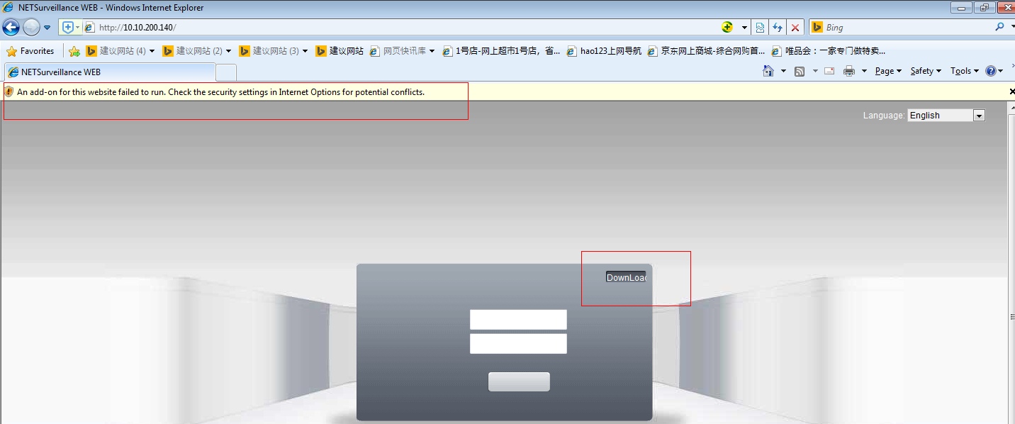

2. Open the options one by one: tools>>Internet options >>security>> custom level and then enable the options with ActiveX . As shown like below:
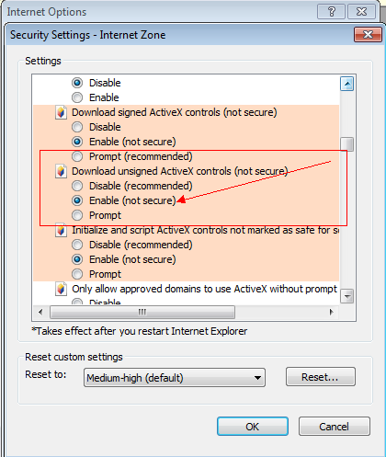

3. After successfully saved, refresh the web page, choose to install the Active control according to clew, as shown like below:
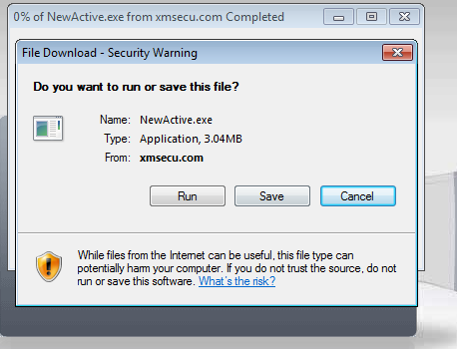

4. After the success of the installation, there will be a login box interface, enter the user name: admin, password: empty. Enter the preview interface. As shown like below:
